

## E-Retail Factors for Customer Activation and Retention

Submitted by:

Vijaya Mukati

ACKNOWLEDGMENT

I would like to express my deep and sincere gratitude towards Fliprobo technologies for providing me the internship opportunity and a great chance for learning and professional development.

I express my deepest gratitude and special thanks to the subject matter expert (SME), Ms. Khusboo Garg who inspite of being extraordinarily busy with her duties, took time out to hear, guide and keep me on correct path ,motivated me for taking part in useful decision & giving necessary advices to do the project and providing invaluable guidance throughout.

Her dynamism, vision, sincerity and motivation have deeply inspired me.She has taught me the methodology to carry out the task and to present the project works as clearly as possible. It was a great privilege and honour to work and study under her guidance. I am extremely grateful for what he has offered me.She was never too busy to spare his valuable time for this work. No words are adequate to express my gratitude to her.

Finally, I would like to express my special thanks to my husband(Deepak Mukati),who has been very supportive thoughout .Also like to thank my families and friends helping me in all aspects and appreciate me to spend my all time in the work place during my internship time.

I perceive as this opportunity as a big milestone in my career development. I will strive to use gained skills and knowledge in the best possible way, and I will continue to work on their improvement, in order to attain desired career objectives. Hope to continue cooperation with all of you in the future

.

# INTRODUCTION

### E-retail factors for customer activation and retention: A case study from Indian e-commerce customers



E-commerce is fast becoming one of the most preferred modes of shopping in India, buoyed by increased customer adoption over the last 12 months due to the Covid-19 pandemic, a new survey shows.  
  
Despite the opening up of local markets, retail stores and malls over the past few months, the findings of the survey by community platform LocalCircles show that consumers who used ecommerce services during the

past year are continuing to use them

Large numbers of customers are getting attracted towards online retailing; this is because e- stores usually offer them a variety of services and products according to their preferences. Convenience, round the clock availability, flexible pricing, discounts as well as free door step delivery are some of the major benefits of shopping online. Presently, more number of online retailers are beginning to experience increase in demand for products and services. . Indian online retail industry has been experiencing good times since the last six years; as a result of the constantly growing internet penetration, deployment of modern infrastructures, and a robust ecosystem for e-retail start-ups several e-commerce start-ups have commenced operation with innovative strategies, which differs from what was pioneered by first generation e-commerce companies.

The decision making by these e-retailers becomes very much important in terms of customer activation and retention. Any wrong decision can lead to high risk for the growth strategies. Hence, there is stringent requirement of research on the dynamics of the Indian online retail industry and coming out with the models for successful development of this industry. The increasingly competitiveness of the online retail industry has led the e-retailers to shift their focus from inducing the consumers to motivate the customers for repeated purchase.

# Customer Activation/Acquisition

## What is customer acquisition?

Customer acquisition is the process of gaining new customers. It sounds simple enough, right? However, it requires a lot of know-how and a team of experts to optimize the process.

Customer acquisition, or client acquisition, is a crucial initiative because, let’s face it, without new customers there is no business! Brands use customer acquisition to understand the value of each paying customer by measuring the money a company spends to bring in a new client. The lower the marketing spend needed to acquire a new customer,   the higher the profit. Companies look at this metric to inform their marketing strategies and improve margins.

Brands ultimately implement customer acquisition marketing to gain new customers, which can include crafting strategies and monitoring outcomes to increase their client base while reducing costs.

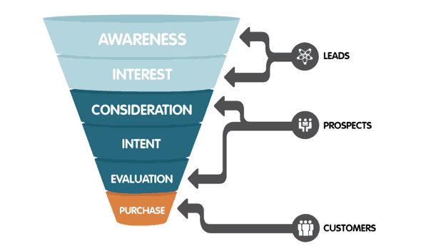

Although each company can design its own customer acquisition strategy, the best way to start is to consider the three phases of the customer journey where customer acquisition happens:

**Discovery:** When customers are looking to address a need, they evaluate different options to satisfy said need. This may be the first few visits to your website, often with the goal of consuming content and learning more about your product or services.

**Consideration:** Actions taken by a customer indicates interest, such as research, browsing, or signing up for alerts and promotions. They are evaluating whether or not your product or service can meet their needs   in comparison to other brands.

**Conversion:** The experience of making a purchase and therefore becoming a customer.

This three-stage process is also known as a sales funnel or sales acquisition process. It’s important to understand how your customers move through this funnel, and tailor your customer acquisition strategy to complement each stage. Keep this in mind as we continue.

## Customer Acquisition Process

The customer acquisition process is just that—the act of acquiring new customers. Your brand should pre-define and design each step of the process. By doing so, you can create a road map to streamline the process. At any given point, a company can monitor certain parts of the road map, identify weak points and optimize for better results.

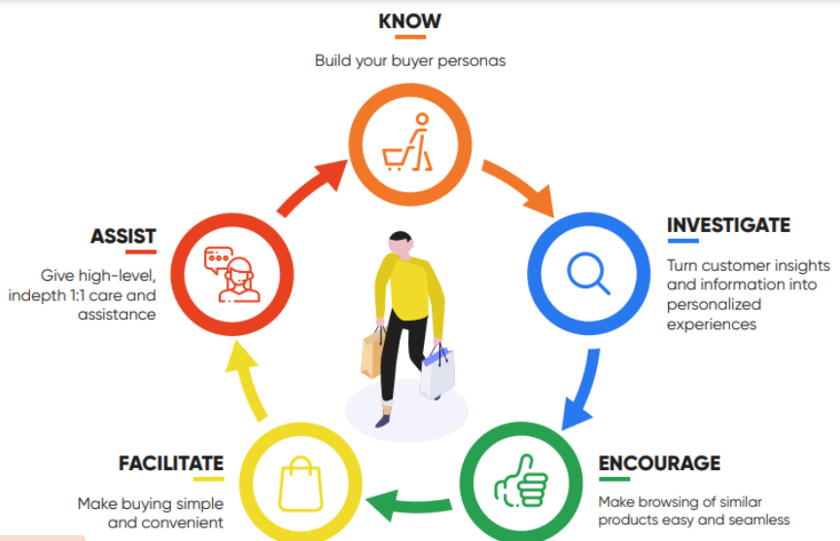

### Step 1: Identify the audience

First, you need to identify your target audience. If you’re targeting multiple audiences, it might be best to design a different sales acquisition strategy for each group.

Moreover, the most successful customer acquisition campaigns have personalized elements catered to the individuals interest, needs or behavior. To identify   and understand your audience, your brand can employ various methods including:

* Creating a target prospect profile, otherwise known as the customer persona
* Conducting market research through online platforms and focus groups
* Analyzing new customer profiles
* Leveraging third-party data from competitors
* Understanding social and search trends for understanding needs of customers using digital conversations

### Step 2: Define your strategy & design a plan

Once you identify and understand your targeted audience, you need to leverage data findings and industry best practices to develop program launch and communication plan. Also, don’t forget to consider which stage of the customer journey your audience may find themselves in. How you message people in the discovery stage should be different than the consideration stage.

To optimize new customer acquisition, your plan should include:

* A cross-channel activation strategy with connected communications across email, display, search, social, mobile and direct mail
* A messaging matrix that considers digital voice and addresses your prospects needs and attitudes
* A testing and measurement plan that defines KPIs such as: impressions, click through rate, new customer acquisition, cost per acquisition (CPA), return on investment (ROI) and return on ad spend (ROAS)

### Step 3: Launch

Once the audience has been identified, the channels have been chosen, and the KPIs are all set, it is time to launch your campaigns. During this part of the process, your company needs to monitor all pre-set KPIs and begin collecting data.

### Step 4: Measurement & optimization

The entire reason to have KPIs in place is to have a clear picture of what is working and what’s not. Optimization should be an ongoing process. The end goal is to eliminate campaigns that do not bring in the best results, boost those campaigns that work well, and eliminate any issues identified through the monitoring process.

For example, if a you find website traffic is high but conversion is low, focus on the landing page and experiment with the content or CTAs.

## Customer acquisition strategies

New customer acquisition campaigns can run both wide and deep with lots to research and test in order to find the best methods for a brand’s target audience. Before getting to this point, brands have to complete a series of self-assessments. This includes identifying their particular acquisition challenges, ideal customers and which channels will work best for both brand and consumer alike.

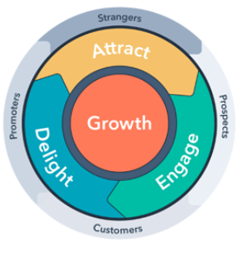

Once this self-assessment is complete, there are various evergreen acquisition strategies that companies can implement to increase their customer acquisition:

* Using video content to increase engagement.
* Do giveaways to increase organic awareness.
* Leverage content marketing to improve SEO and keep prospects engaged.
* Use consistent branding and clear communication to increase trust and authority.
* Run referral programs.
* Implement a reward program to increase client retention.
* Create an affiliate program.
* Build partnerships and utilize their leads to promote your product/service.
* Use landing pages when launching new products to highlight them and help customers focus on the new solutions the company is bringing to the market.
* Implement newsletters to collect leads and subscribers to minimize marketing costs.
* Publish content on external websites.
* Leverage influencers that reach your target audience and align to your brand voice.
* Ensure paid search campaigns are optimized based on product, audience and geographic location

It’s important not rush into any one acquisition tactic. Rather, take a step back and do the research, build out your acquisition channel matrix and growth model, and then put into play some minimum viable experiments to see what starts to gain traction.

# Customer Retention

### What is customer retention?

Customer retention is what organizations do to stop customers from churning or switching to a competitor. Increasing customer loyalty is a key goal of any business and contributes greatly towards sustainable growth. Despite this fact, and irrefutable evidence that existing customers are more valuable than new ones, customer retention has often taken a back seat to driving sales.

But this trend is changing, especially given the rise of subscription-based business models. There are clear competitive advantages of customer retention, and we’re here to help you understand how and why the benefits of customer retention should be on your radar.

Preventing customer churn is in essence the main objective of most customer experience programs, and often the most tangible one.



# Benefits of customer retention

## 

1. **Support sustainable company growth**

As we’ve already seen above, customer retention contributes heavily towards sustainable company growth. It lowers costs and increases profit. In financial services, for example, a 5% increase in customer retention produces more than [25% increase in company profit](https://www.bain.com/insights/prescription-for-cutting-costs-bain-brief/). And sometimes that increase soars to nearly 95%. Although that impressive statistic varies across industries, a good customer retention program will repay your efforts in spades.

1. **Increase the value of each sale for each customer**

 By investing in customer retention strategies (e.g., through a loyalty program), you can increase CLV (Customer Lifetime Value) as well as your chosen customer retention statistic or metric – the longer customers stay loyal, the more they tend to spend. Because you’ve already paid the cost of acquisition, your ROI grows. This applies to all profit channels – e.g., spend, or indirect—e.g., referrals of new customers.

1. **Get more insight into your customer and why they do what they do**

Historical data from customers (behavioral data, purchase history) can really help organizations make better business decisions. With customer data, you can understand why a certain customer action means a particular result, predict likely purchasing trends, see where the market gaps may be, and identify opportunities for improvement—across the board.

1. **Boost referrals and strengthen customer loyalty**

Loyal customers are more likely to act as references, generate positive word of mouth contribute towards new acquisitions. We all know the power of a personal recommendation, so leverage that to build your business. When you get that reference—use it! New customers are far more likely to trust a testimonial than your sales pitch, so boost your marketing with plenty of first-hand accounts about how good your product and service is.

1. **Reduce your cost of acquiring new customers**

It’s cheaper to keep customers than try to acquire new ones. Plus, it’s easier to market to customers you already know well, then learning about new ones. The cost of acquiring a new customer can be anywhere between 4 and 10 times that of keeping a current one—depending on the source. No matter how you slice it, it’s clear that smart businesses make sure customer retention is a key focus.

1. **Develop better products, faster**

 Customers who come back help you understand what’s working with your products, and what’s not. For example, which products or services do they go for, and which ones they avoid. Asking why can offer insight into your product development and refinement and means you can sense-check what you’re doing at every step of the way. Make sure you’re hitting all aspects and asking your customers at multiple touchpoints to get a full picture. Go beyond the exit survey and ask questions much earlier in their customer journey.

1. **Reduce customer churn that weighs down sales growth**

Customer churn can cost you. A high churn rate weighs down your entire sales team’s growth rate; from the cost of acquiring a new customer, as discussed above, to missing out on the higher rate of selling—a current customer is far more likely to buy from you than a new one. But customer retention can be boosted with a few simple tactics like offering incentives for your longest-standing customers or deploying your best customer service reps to work with customers-at-risk.

1. **Experiment safely with customers who are open to change**

Because current customers trust you, and your product, you can try out new things. That trust gives you space to experiment with new products or services, that customers are more likely to try as soon as you launch. Bottom line, a loyal customer is [23% more likely](https://www.gallup.com/workplace/311870/customer-centricity.aspx) to spend with you than your average customer. You can offer loyal customers beta testing, or a discount on a new product or service. Make them feel special and you’ll reap the rewards.

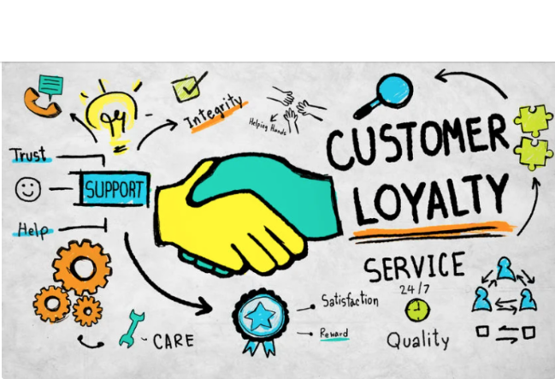

### 

### ****Retaining customers****

You need to fight on multiple fronts when it comes to preventing customer churn:

* Ensure your communications channels are easily accessible to your customers. It needs to be as easy as possible for them to get in touch with you when things go wrong, via the channel of their choice.
* Build Customer Success strategies for your account management teams – focusing not only on customer retention metrics, but more importantly on the value your customers get from your products and services
* Put in place a [Voice of the Customer](https://www.forsta.com/platform/voice-of-customer/) program that focuses on measuring customer experience – a program that will put powerful insights in the hands of those who can take action and drive improvements at every stage of the customer experience journey.

## 

## 8 Factors that Affect Customer Retention

### 1. The Original Purchase Experience

Will your buyers remember their experience with you as easy and enjoyable, or complicated and

stressful? This will influence whether they purchase from you again, or leave in search of a better

option.

There are plenty of factors that go into the [customer journey](https://rachelandreago.com/customer-journey-content/), but there are a few main things to focus on to provide a seamless experience.

* **Product discoverability**: Figure out where your audience likes to shop and make sure you sell on those channels.
* **Website navigation**: Make it easy to [explore your website](https://hawkemedia.com/services/web-design/?) and find what they’re looking for. Don’t confuse shoppers with complicated page navigation and too many menu options.
* **Inventory availability**: Stay in stock, so shoppers can get their items ASAP. If you can’t [avoid going out of stock](https://www.linnworks.com/blog/demand-forecasting-stock-control), provide [backorder options](https://deliverr.com/blog/backordered-products/).
* **Payment options**: Give your shoppers the option to pay how they want to. You should allow guest checkouts, and multiple payment options like PayPal, Apple Pay, and the standard credit card checkout.

### 2. Delivery Speed and Reliability

More than one-third of shoppers [won’t return to a retailer following a lousy delivery experience](https://info.metapack.com/rs/700-ZMT-762/images/Metapack%20H2%20Report.pdf) — making shipping a key customer retention factor. Delight your customers with fast and free shipping, tracking information, and reliable delivery.

### 3. Customer Service

Nearly half of customers [buy more following a good customer service experience](https://www.salecycle.com/blog/strategies/the-importance-of-customer-service-for-loyalty-and-retention/) — even if that experience involved an initial complaint. Not all customer service has to involve a complaint either – you can provide customers with proactive support that makes them feel valued.

Examples of [proactive eCommerce customer service](https://deliverr.com/blog/set-up-ecommerce-customer-service/) include hassle-free returns and pre-paid postage, a post-purchase email that includes instructions for use, and a feedback survey.

### 4. Convenience

[Two-thirds of shoppers](https://www.forbes.com/sites/shephyken/2019/10/13/customer-loyalty-and-retention-are-in-decline/?sh=66ad28574329) are more loyal towards brands that make it easy and convenient for them to re-engage with. Finding, researching, comparing, and signing up to online stores and marketplaces is time-consuming, so it makes perfect sense to want to save some time if they discovered a convenient shop.

### 5. Incentives

There’s nothing more frustrating for an existing customer than seeing new customers treated better than they are.Repeat customers want a reason to shop with you again and to be [rewarded for their loyalty](https://hawkemedia.com/insights/ecommerce-loyalty-program-pro-tips/?). When you’re saving money on marketing, customer retention incentives don’t have to break your profit margins, either.

### 6. Personalization

You already know [personalization](https://hawkemedia.com/insights/personalized-marketing/?) is essential for sourcing customers. It makes them feel valued and special. Your existing customers are no different. Plus, you already have their information, which makes personalization a little bit easier.Interact with your existing customers on social media, send them curated product recommendations, celebrate their joining anniversary, and send them relevant marketing campaigns.

### 7. Marketing

Just because existing customers know about your store doesn’t mean you should stop marketing to them. You must still grab their attention in their inboxes, on Google, and via social media to remind them about your store and attract them back to your product pages.

This includes:

* Sending targeted email, SMS, and push notification marketing campaigns
* Optimizing your social media ads with standout information, such as dynamic fast shipping tags
* Using [eCommerce SEO tactics](https://deliverr.com/blog/ecommerce-seo-best-practices/) to rank high for relevant keywords on Google
* Qualifying for fast shipping programs, such as [Walmart TwoDay](https://deliverr.com/blog/walmart-2-day-shipping/), to increase visibility on online marketplaces

### 8. User-Generated Content

Have you ever gotten that warm fuzzy feeling when a brand you love shares your review, photograph, or Instagram story and tags you? Your most loyal customers feel the same.

User-generated content is social proof that attracts new customers to your social media profiles and D2C store. It’s also highly engaging for existing customers, especially if they’re the star of the show.By showing your appreciation of existing customers, and showcasing their content around your brand, you create trust and familiarity that leads to repeat purchases.

# Importance of customer acquisition and retention

Customer retention measures not only how successful a company is at acquiring new customers but also how successful they are at satisfying existing customers. It also increases ROI, boosts loyalty, and brings in new customers.

Acquiring new customers is a driving force that motivates all companies, but it's not without its limitations. For a business to thrive, it must eventually shift its focus to retaining the customers it has acquired rather than only landing new ones.

A client or customer who stays with your company over time gives you the chance to provide more ongoing value, develop more personalized content, nurture a brand advocate, gain referrals, and earn positive word-of-mouth marketing.All of this is in addition to the fact that [68% of new customers come from current ones](https://www.semrush.com/blog/customer-retention-stats/), making it a smart move for your customers and your bottom line to keep current customers coming back.It's also easier and more cost-effective to retain customers than to acquire new ones, returning customers spend more and buy more often, and refer friends and family.

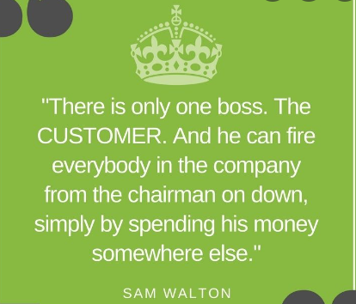

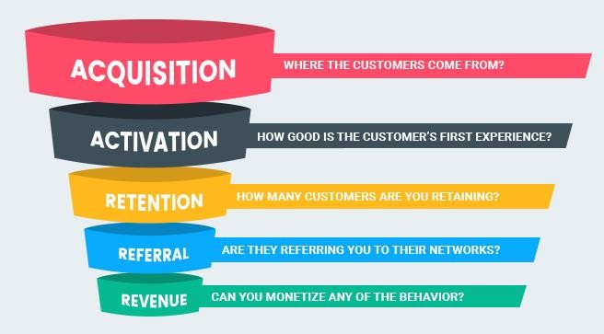

Obviously, customer acquisition is important, but unless you are focusing on all aspects of their customer journey, you are going to have a revolving door business model. While cutting down costs is always good, it isn’t always a good enough reason to shift focus completely to a retention-based model.

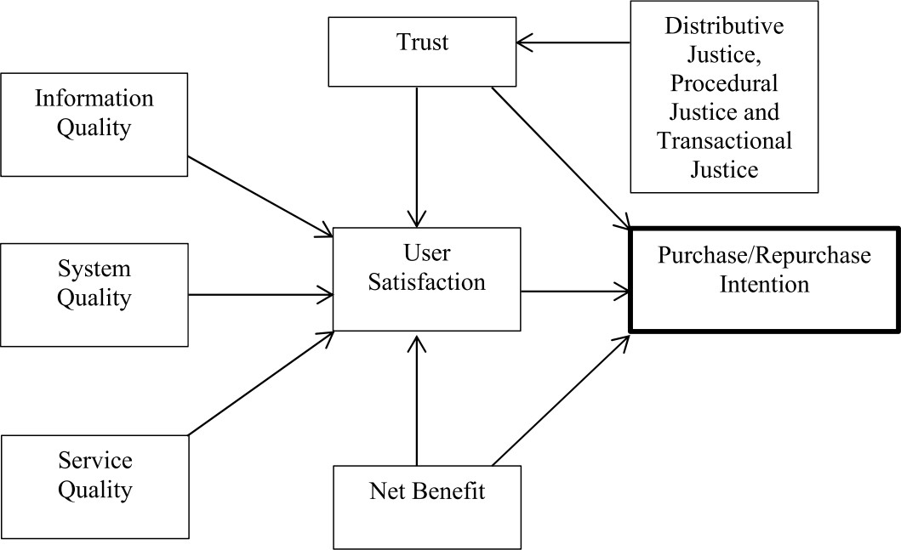

**Fig: proposed customer activation model**

Knowing how to maximise the repurchase intention of Indians online consumers’ is vital for an online retailer in India to achieve its business goals. This may further lead to develop a general reference model for successful online retail business.

Moreover customer retention is more futuristic than customer satisfaction. It focuses marketing efforts to current customers. Due to stagnant markets, decrease in population growth, and increase in the cost of marketing and advertising customer retention becomes of utmost importance.

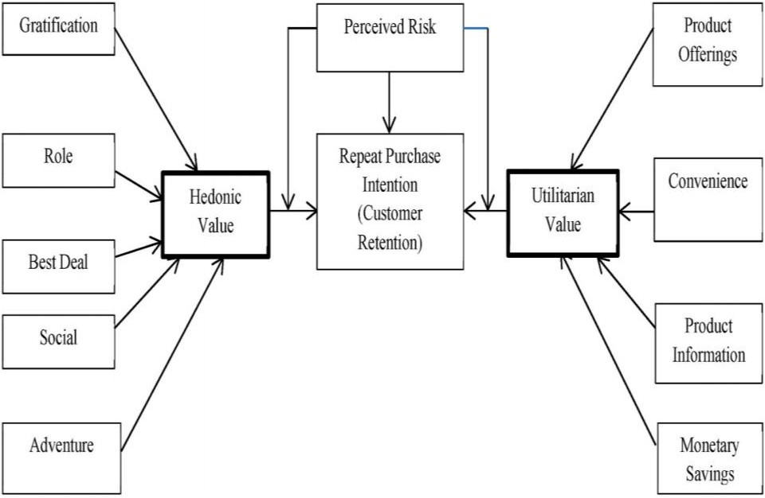

### Fig: Proposed customer retention model

Customer retention rate measures how many existing customers are still with you at the end of a certain period. Getting an order from a current customer is easier and less expensive than attracting and converting someone new. High customer churn with low customer retention means customers are going out your back door quicker than they’re coming in the front door.

# PROBLEM DEFINITION

The primary objective of this study is to propose and empirically test the online retail success model with emphasis on proving values to the customers.

The data is collected from the Indian online shoppers. That indicates the e-retail success factors, which are very much critical for customer satisfaction. We will be applying analytical skills to give findings and conclusions that incorporates the factors necessary for user satisfaction, which in turns leads to purchase/repeat purchase intentions and explains customers motivational values necessary for repurchase

The project work has focused upon hedonic and utilitarian values and attempted to see their role in the customer satisfaction and purchase decisions. The combination of both utilitarian value and hedonistic values shall explain customer’s motivational values necessary for repurchase and most importantly how these values may differ from one customer to another.

# Conceptual background

In order to tackle the problem statement /question posed we draw on literature regarding online shopping motivations and purchase intentions.

Motivation is the reason that leads people to do something. In the shopping process, when the consumer wants to meet the need to be activated, the motivation is generated. Shopping

can satisfy people’s biogenic needs for food, water and houses, as well as psychogenic needs for power, status and pleasure. Therefore, when different needs generate, here comes the different motivations. The shopping motivation is not a new research subject. Many scholars have measured the motivation of shopping by using two major dimensions, utilitarian and hedonic attributes.

Consumers who hold utilitarian shopping motivation perceive shopping as a task. Thus, they are rational, pursue the objective characteristics of products, and achieve a specific goal.

Meanwhile, consumers who hold hedonic shopping motivation regard shopping as a source of enjoyment and pursue something new, emotional satisfaction, and symbolic meanings of features. A website’s positive affect is related to both utilitarian and hedonic shopping value, impacting share of purchase.

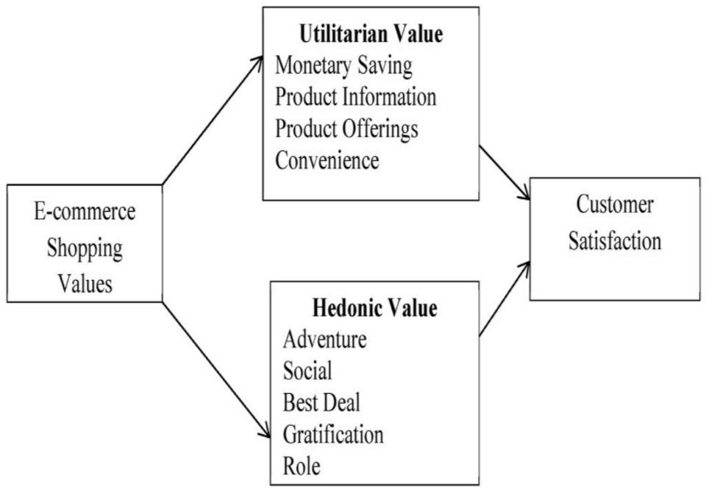

### Fig: E-commerce shopping values

Thus the utilitarian shopping motivation pursues whether the consumer’s demand that stimulated the shopping is satisfied. The hedonic shopping motivation cares about the emotional pleasure of shopping as perceived by consumers.

# Data analysis

To begin with we shall import the dataset into our Jupyter notebook .The data characteristics/dimensions etc. are studied using the following commands:

1. Df.shape: The shape of dataset is 269*71 i.e. it has 269 records and 71 columns
2. Df.dtypes: Expect for “pin code” all other columns are object data type. Pin-code is integer data type.
3. Df.info: gives all other related info about the dataset including null values, memory usage, and data type of each feature.
4. df. isnull ( ).values. any ( ) : Check if there are any null values in the dataset ,in our case there are no null values present and the data is clean.
5. The value_counts method is used to identify and count all the unique values present in each column/feature of the dataset.

**We shall perform analysis of the entire dataset by grouping all the features as per the hedonic and utilatirian for ease of understanding and visualization**.

# Hedonic values

Consumers expect a more social and interactive online experience to accumulate common intelligence and support decision-making. The hedonic aspects should be taken into account in designing the Website of a fashion retailer.

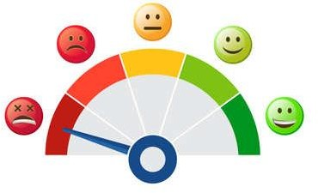

Dimensions of hedonic values include;

* 'Empathy’,
* ‘Enjoyment derived',
* 'Satisfaction'
* ' Trust',
* 'Sense of adventure',
* 'Enhancement of social status',
* 'Gratification',
* 'Fulfilment of certain roles',
* 'Access to loyalty programs' etc.

# Visualizations:

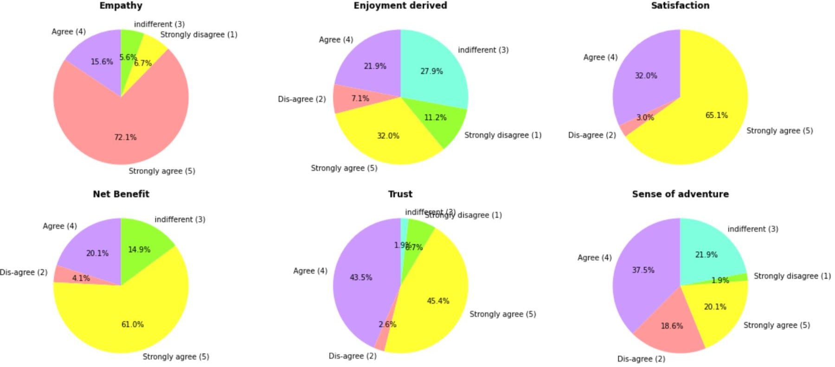

**Empathy:** Empathy towards the customers shows the readiness to assist with queries) helps uncover (interpret) and make sense of what users were saying and what our observations from their actions indicated.

Empathy means understanding what your users need and offering helpful and easy-to-find tutorials, help docs, and even educational material that will help them not only use your app like a pro, but also succeed in their roles.

If we want to build empathy, we have to imagine and visualize ourselves and others using the products, day-in and day-out,

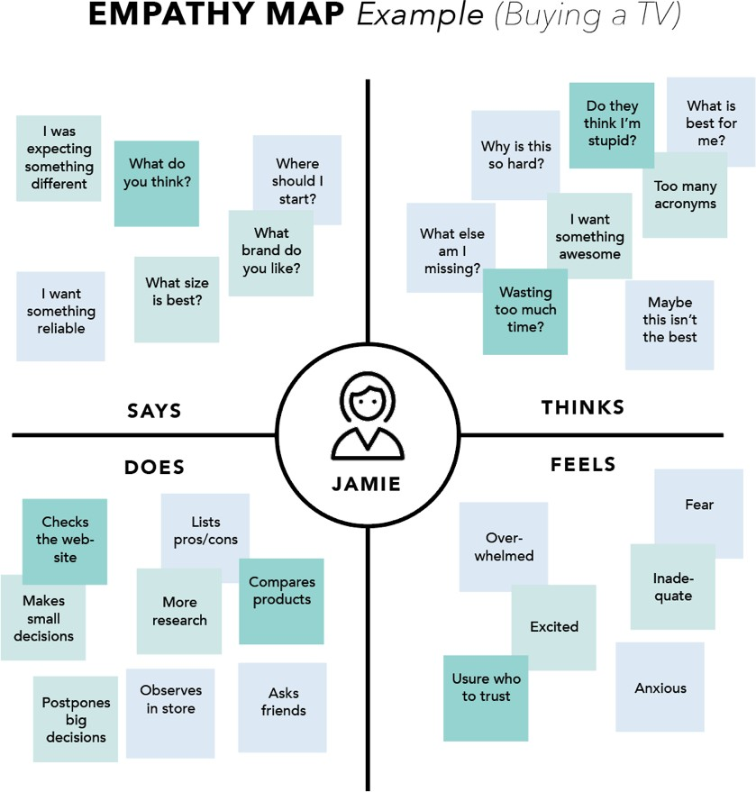

#### Observation for empathy (readiness to assist with queries) towards the customers:

* About 72 % people feel that empathy (readiness to assist with queries) towards the customers is an important aspect for customer retention.
* A very small portion of the population i.e. 6~7% have indifferent views for the same.
* The majority could be seen agreeing to the fact.

**Enjoyment derived**: Shopping enjoyment can be viewed as the pleasure that a consumer derives from the shopping process/activities. It is the degree, to which an e-store is entertaining and fun to the online customers. Pleasure is also derived during the process of browsing for good deal, ability to compare products, prices, etc.



#### Observation for Is Enjoyment derived from shopping online:

* Majority of share represents the strong agreement that means people do enjoy online shopping.
* 27.9% of the records say people have indifferent views on the same.
* A very few people could be seen neglecting the enjoyment factor derived from online shopping i.e. 11.2 %( strongly disagree).

**Satisfaction:** Customer satisfaction is the central, most important aspect of

achieving business success. Unlike other industries, internet retail improved in customer satisfaction, climbing 1.3 per cent to an Index score of 81. More than anything, consumers appreciate and are satisfied if there is easy the checkout and payment process with internet retailers, as well as the quality of their mobile apps. There are various other factors which lead to customer satisfaction like

* + System quality
  + Information quality
  + Service quality
  + Product quality
  + Delivery service
  + Savings
  + Product return

#### Observations for Do User derive satisfaction while shopping on a good quality website or application?

* Thus majority of them are satisfied while shopping if the quality of website or application is good.
* The survey states that there are no people who would like the quality of retail website to be in poor condition.

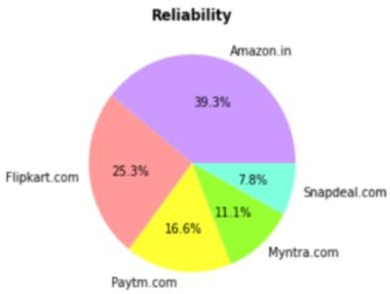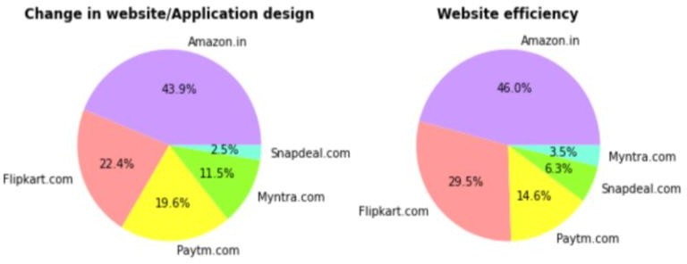

***Observations***

* 39.35% people considered amazon as most reliable website for online purchasing which was the maximum.
* Flipkart had the second most highest votes in terms of reliability
* The least votes were given to snapdeal (7.8%)
* Amazon made more number of changes in the website or design and still maintained maximum efficiency.
* Snapdeal had the least changes in website/ application design its efficiency was 6.3%.
* Myntra was given the least efficiency

**Sense of Adventure** :This type of shopping is engaged in by an online customer who is looking to escape bored therefore requires stimulation to get out of depression (Bridges and Florsheim 2008).A survey conducted shows that, 95% of respondents agreed that shopping online serves an opportunity for departure from daily routine.

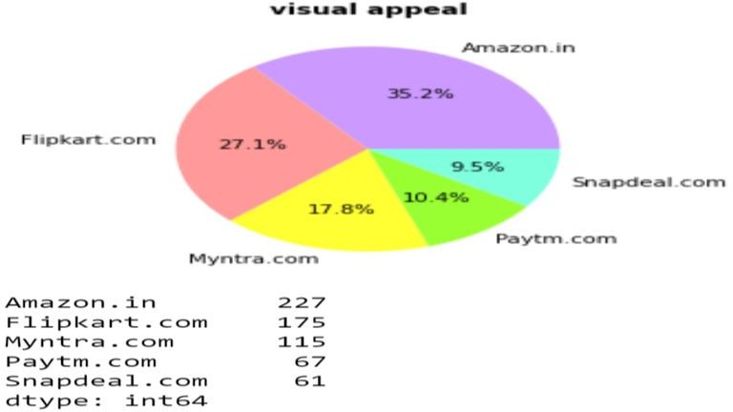

#### Observation

* Visual appeal is what meets the eye. It's the colours, shapes, pictures, fonts, white space, and overall visual balance of a design. Whether a website appeals to us affects how we perceive it, how we use it, and how we remember it
* Amazon and flipkart were the ones who were considered visually appealing by the customers.
* paytm and snapdeal were less attractive and seeks less attention

**Trust:** User satisfaction cannot exist without trust, building trust with customers is key— especially since trust is the first principle of conversion.



There are various steps one can take to establish trust on ecommerce sites or apps, to reassure and engage customers. Few of them include:

* + Make a good first impression: ensuring that the website looks beautiful across all device sizes. It should be fast, with easy-to-absorb content, inspiring imagery, and simple navigation.
  + Use trust signals: Use clear trust signals such as third-party reviews (for

example TrustPilot and Feefo), security seals, free returns, and a physical location on contact page to reduce any perceived risk. Even adding a picture of the client or their team to the ‘About Us’ page can provide some extra reassurance**.**

* + Good customer support, etc.
  + Make the ecommerce experience accessible: “If a user has difficulty using a product because they are disabled, they may feel a loss of trust in that product or brand Ambiguous messages, unclear instructions, complex custom controls, reliance on visuals, and inconsistency may be barriers.

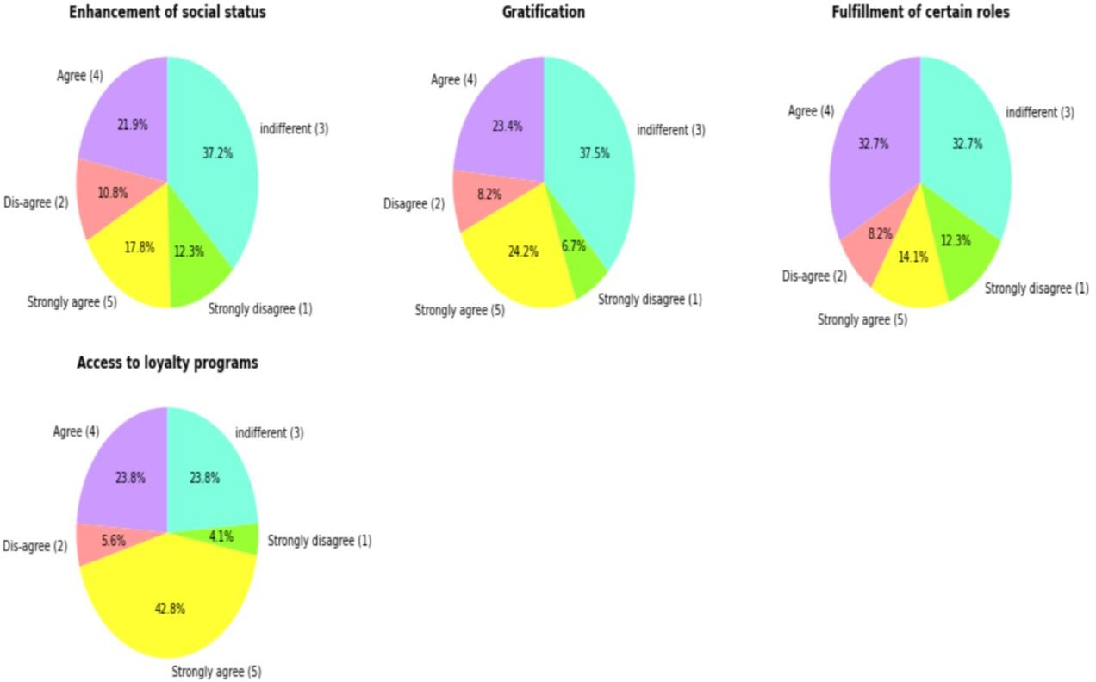

**Gratification**: gratification is a strong motive to shop online; it also improves the chances of buyer returning for a repeat purchase other products from the same e-retailer. There is a feeling of accomplishment after completing a task easily on the website. Other form of gratification includes receiving incentives for shopping on a particular website.

#### Final observations:

* Similarly for adventure gratification, enhancement of social status and fulfilment of roles most of the respondents voted for "agree “and "strongly agree" which shows how the people perceive online shopping.
* Thus maximum number of people strongly believe that gaining access to loyalty programs is an added benefit of shopping online

# Utilitarian values

Utilitarian value is also called as functional value and is associated with the functional benefits that a customer gets from a product. When a customer is buying something that gives them utilitarian values, it basically means that the particular product they are buying is giving them some functional benefits



Whenever a customer thinks about a purchase, they think about it in terms of why they are buying it .If they are buying for a certain function then that’s a utilitarian value. But if they are buying it for some experiences or psychological benefits, then in that case it is a hedonic value.

Utilitarian values consist of the following aspects:

* Monetary benefits/gains
* Product information
* Product offerings
* Convenience

1. Monetary benefits and gains

**Monetary benefits and discounts**: To attract customers to shop online, e-retailers and marketers should offer discounts to the customers. Due to elimination of maintenance, real- estate cost, the retailers are able to sell the products with attractive discounts through online. Some sites also allow free delivery for their premium customers.

**Monetary savings**: With ever-increasing gas prices, shopping online saves you the cost of driving to stores, as well as parking fees. Irrespective of partnerships with shopping websites,

your bank may have on-going offers if you use your credit / debit card during a certain period, or above a particular amount per transaction. Monetary savings could be in the form of discounts, cash back, vouchers for shopping, movie tickets etc., or even in the form of bonus reward points.



New wallet and payment apps also keep sending emails and notifications for offers if payment is made from their app. check the Offers section in those apps as well for latest shopping deals. One can also set a label or filter to keep track of such emails to get maximum value when shopping online during a sale.

**Net benefits:** This is used to describe the total benefits received when shopping online by customers, as against the costs (for example, effort, money and time). Some of the net benefits derived from online shopping include: monetary gain, product search and buying effectiveness, convenience, timely delivery, enjoyment, broad product range, and flexibility. According to a research by Childers et al. (2001), net benefit of shopping online includes both utilitarian value and hedonic values.

## Visualizations for monetary benefits and gains:

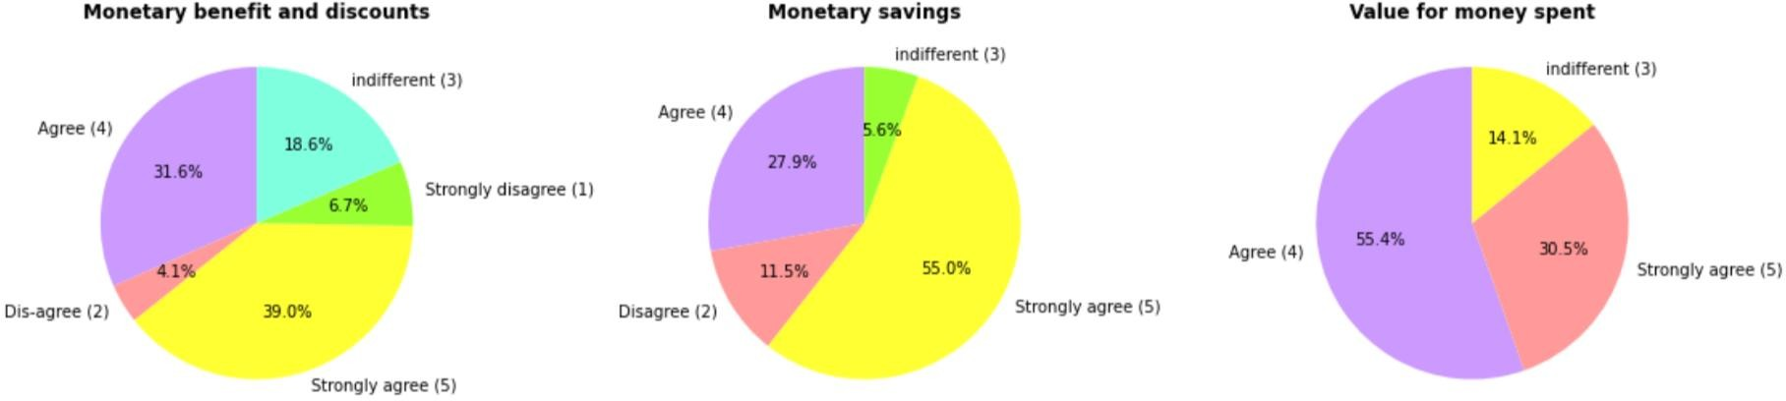

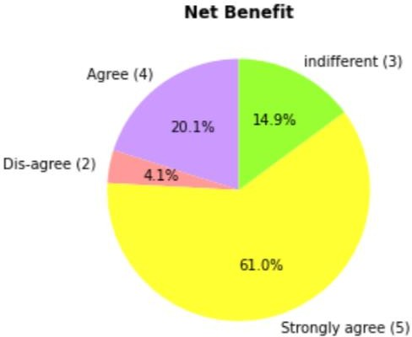

#### Observations from the visualizations:

* From all the 3 plots above it is quite clear that people usually prefer saving money and tend to get attracted for higher monetary savings
* There are very few records of "Disagree" and "strongly disagree" in all the above features.
* Few people have indifferent point of view as it might be possible that a product that leads to monetary savings would demand compromise with the quality.

## Convenience:

From an end user's perspective, **ecommerce websites** should be **convenient** to purchase products and services **online**. The process should often be very quick so the customers can place orders in a relatively short period of time, without having to leave their homes or offices.

Many e-commerce researchers have found and selected convenience as an important factor at online shopping and consumer behaviour. Customers should take benefits of faster searches, easier comparisons, ease of navigations, user friendly interface, easy to understand content and more choices.

## Visualizations for Convenience:

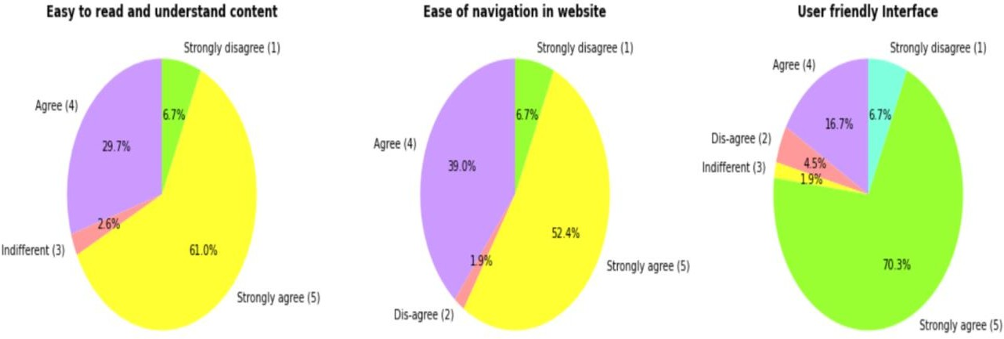

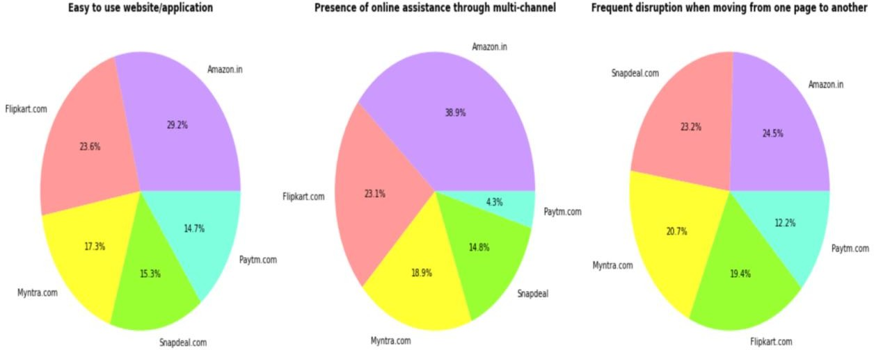

#### Observation:

* + Frome the plot above it is visible that the majority share belongs to "agree" and "strongly agree”. This states that people strongly believe in e-retail websites to be convenient.
  + Various factors that led to convenience were Easy to read and understand content, Ease of navigation in website’, User friendly Interface, Responsiveness/availability of communication channels, Convenience/flexibility, Return and replacement policy and Convenience of patronizing.
  + The content should be easily understood and read in order to avoid confusion
  + User-friendly interface ensures that the person accessing website feels it easy to understand and use the application/interface
  + Ease in navigating the web pages and flexibility increases the overall user- interface.
  + Web site information convenience is an important factor to attract customers and make a connection between them and company’s product or services
  + Thus amazon and flip kart were considered more convenient in terms of ease of use, presence of online assistance.
  + There were frequent disruptions while moving from one page to another in amazon and myntra.
  + Amazon provided great online assistance from various channels.
  + Paytm has shown smooth transaction while moving between pages.

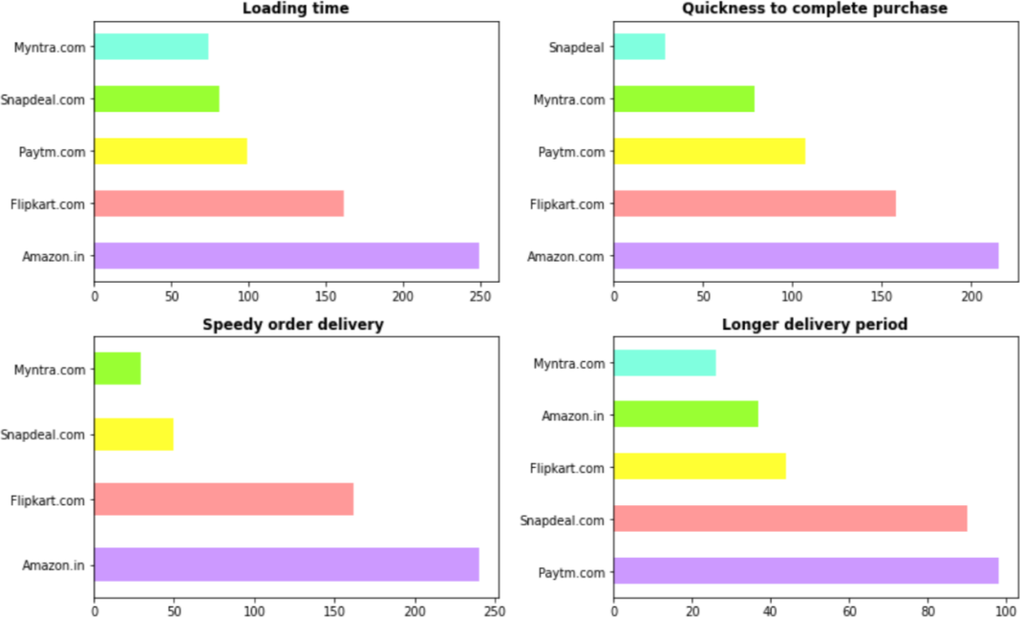

#### Observation for loading time:

* + Therefore we can conclude that the Fast loading website/application was amazon.in followed by flipkart
  + Myntra has the lowest votes in terms of loading speed

#### Observation for quickness to complete purchase order:

* + From the plot it is clearly visible that the amazon websites showed quickness to complete the purchase order the most.
  + snapdeal was the one which got least votes for quickness to complete the purchase order

#### Observation for speed of delivery:

* + people preferred amazon as the one providing speedy delivery
  + Flipkart too had many records in terms of speedy delivery
  + Myntra can be seen as the slowest one

#### Observation for Longer delivery period:

* + The fastest delivery was made by Myntra followed by amazon and flipkart
  + Paytm and snapdeal took longer time in delivering the purchase orders to customers.

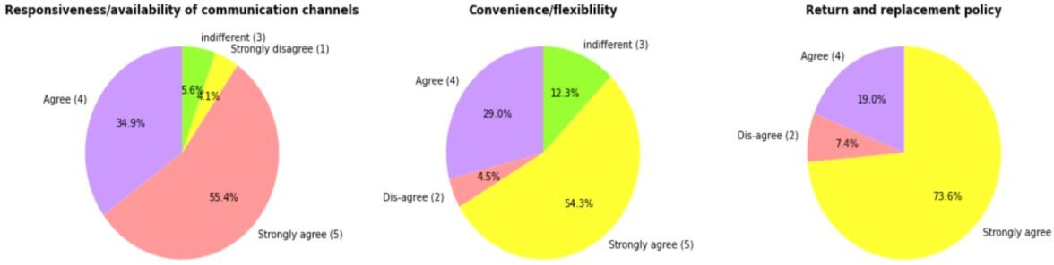

* + People are more satisfied if there are good provisions for return and refund on the purchase orders.
  + In case if the customer faces any query during the time he is exploring/purchasing from the website there should be proper communication channels for quick response.

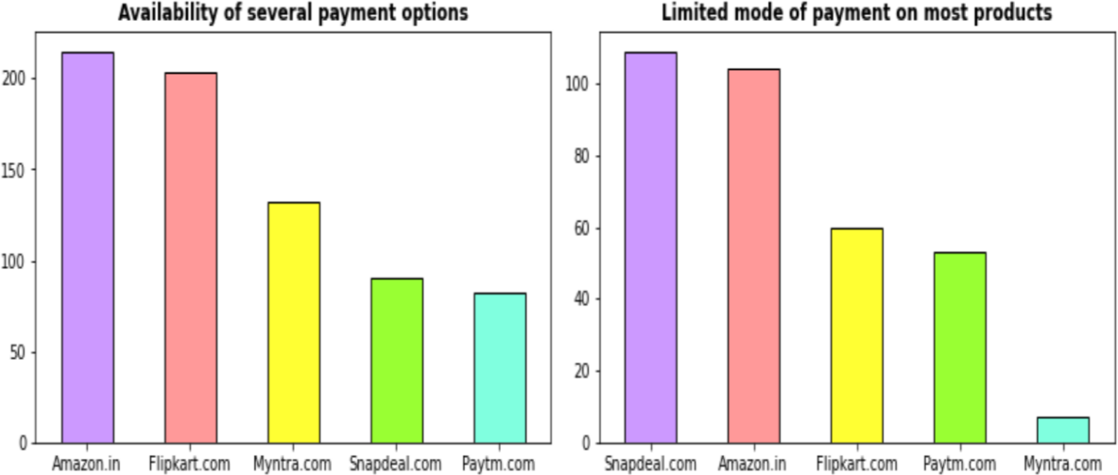

#### Observation for availability of several payment options:

* + "Amazon.in" and "FlipKart.com" provided a wide variety of payment options on their website/application.
  + "Paytm.com" had the least payment options available
  + people also voted "Snapdeal.com" for less number of payment options available

#### Observation for Limited mode of payment on most products (promotion, sales period):

* + snapdeal and amazon had very Limited mode of payment on most products (promotion, sales period)
  + Myntra provided various modes of payment even during the period of promotions and sales

## Product information

System information and service quality is important for customers when making the decision to purchase. Information quality Information Quality can be defined as the customers’ perceptions towards the presentation and characteristics of information presented or displayed in an e-commerce website, web application or portal. It takes the characteristics of information into consideration, for example, timeliness, relevance, understandable, accuracy, and completeness.

One of the basic responsibilities of an e-retailer is to ensure the availability of complete information on products being offered, the transactional process involved, and services to be rendered. Displaying high quality information on the website can stimulate and improve conversion rate as well as lead to better customers’ satisfaction. However, out-dated or

inaccurate information can lead to customers’ dissatisfaction.

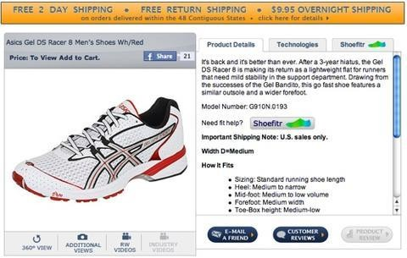

### Fig: Product description

The increased information on the web has the potential to result in more knowledgeable customers who are able to make better decisions and will experience more satisfaction with their purchase. More detailed product or service information will lead to a better purchase. Information richness focuses on information about buying and reduces search time. With providing easy and clear view of information, customers can have lots of options to buy service or goods.

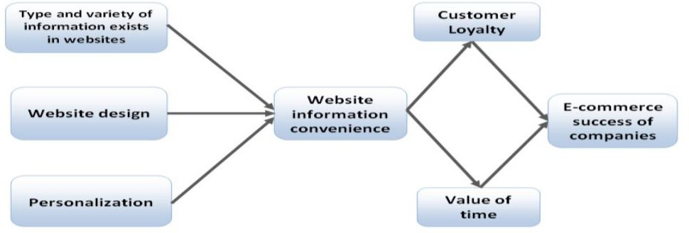

### Fig: Factors that has effect on website information and impact of website information on e-commerce success of company

6 out of 10 online shoppers point to poor product content as the main cause for leaving a shopping cart, besides price and delivery times. The worst part is that in most cases those users will never come back to a shop that has not lived up to their content expectations.

Giving rich product information to users, with enough data that covers every detail of the product, and complementary materials that compensate for what is missing in a non-physical shopping experience (videos, tutorials, user reviews, AR…) is the key to convince the shopper to not leave at the checkout and ensure them a better online experience.

Remember that product information is not just numbers, technical specifications and texts — it’s everything that tells something about products, including testimonies, reviews, visuals, audio, and other multimedia assets. It’s a complex ecosystem, which differs in each industrial niche and that one must keep polished and well cared for.

If a product page and e-commerce store has all the information any user is looking for, the probability of finding the correct product increases. Every product page must include the basic information for its niche, and a bit more: a complete and reliable sizes and measurements chart system, lists of composition, ingredients or allergens, a rich gallery of images from different angles, detailed zoom, visual user guides, assembly or installation instructions, and a studied photo retouch that shows the product under the correct light.

# Visualizations

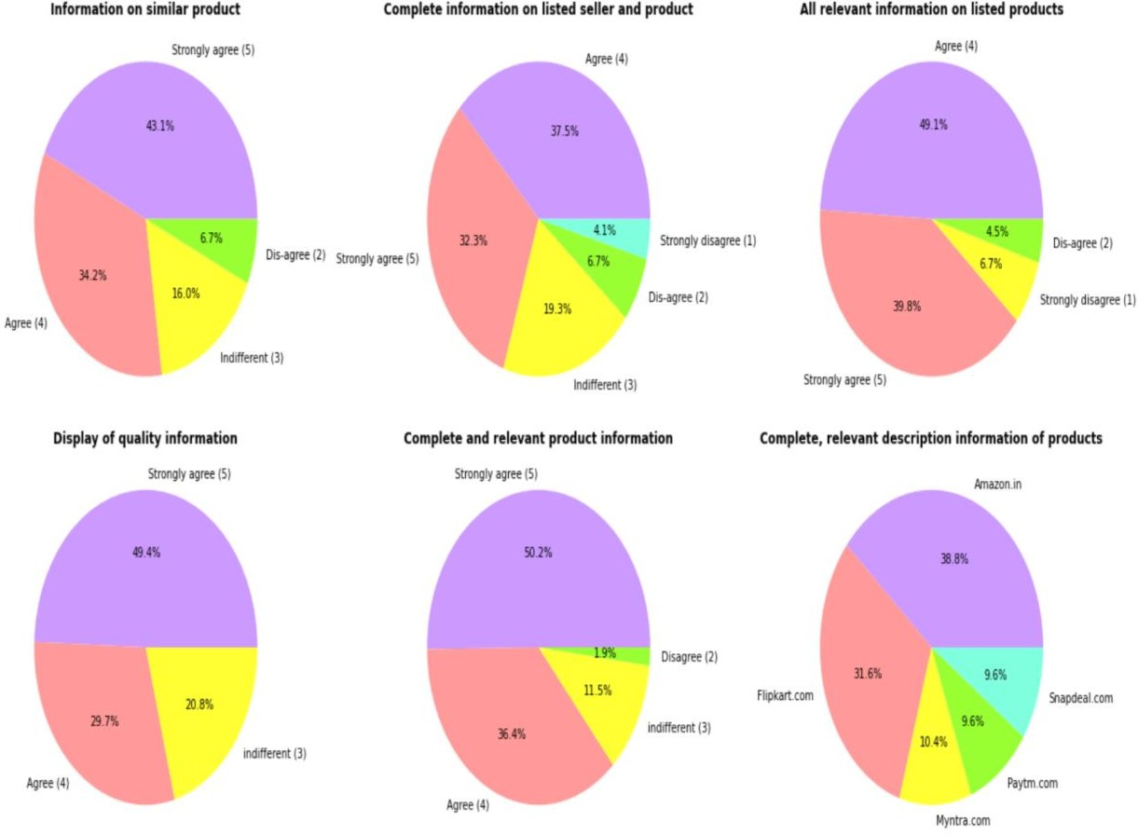

#### Observations:

* From the first four pie charts it is very clear that the highest percentage is dedicated to "Strongly agree" and "agree", which states that people usually look for e-retail websites which can successfully provide complete and relevant information on all the products, the information should be clearly stated so that customers can compare each product's information and make purchase decision.
* Thus displaying quality information will ultimately lead to customer satisfaction
* Among the entire mentioned e-retail website "Amazon" and "Flip kart" provided good piece of information on their products.
* Myntra Snap deal and paytm did not provide much relevant information on the products.

# Product offerings

Product offerings is described as the complete information on products or services offered for purchase to a customer by an online retailer, while displaying the height, depth, and breadth of the merchandise being offered .Take for instance, a customer shopping on flipkart.com will be shown different categories of product (for example, Smartphones, computers, fashion etc.) to choose from, several option of any product choose is available for comparison.

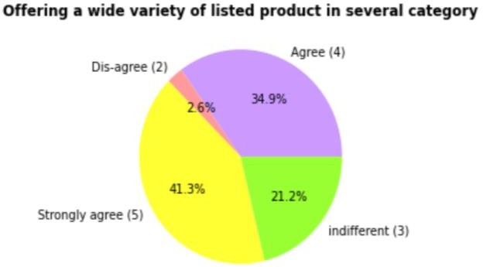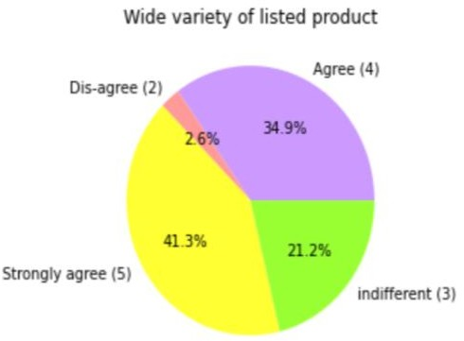

#### Observations products in several category

* + People are more attracted to e-retail shopping if there are a wide variety of products in several categories.
  + 41.3% is the largest share which defines the population that strongly agrees.
  + Only a 2.6% people of total population disagree to the same

#### Observation for wide variety of listed product

* + People tend to buy more from e-retail websites if there is a wide variety on the products that are listed.
  + Few people (21.2%) had indifferent views.
  + A very small portion i.e.2.6 % dis-agreed that the variety will lead to customer retention.

**Perceived Trustworthiness:** trust is deemed crucial for turning site visitors into buyers. When engaging in online transactions, customers have to rely on the promises given by the online retailer. For example, customers do not know in advance whether an ordered item will turn out exactly as what they wanted .Also, customers have to trust that their personal information will not be passed on to other parties, or that their credit card information is safe from hackers .As the online environment features many possibilities for fraud customers are generally eager to find out before any purchase whether a particular online shop is trustworthy or not. Consequently, trust has received a lot of research attention and has been identified as a key driver for the success of electronic commerce

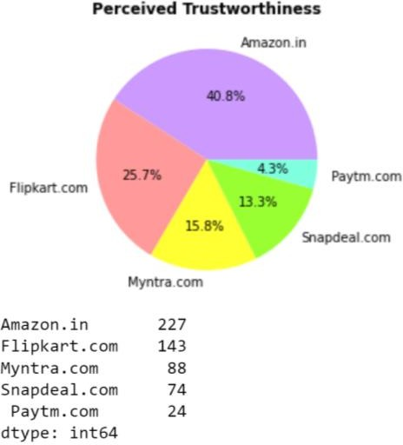

#### Observations for perceived trust:

* + - From the available e-retail websites Amazon and Flip kart are considered more trustworthy.
    - Paytm was not much successful in building customer trust
    - The more trustworthy an online vendor is perceived by a customer, the more likely this customer is to take an actual financial risk towards this vendor.

# Recommended website:

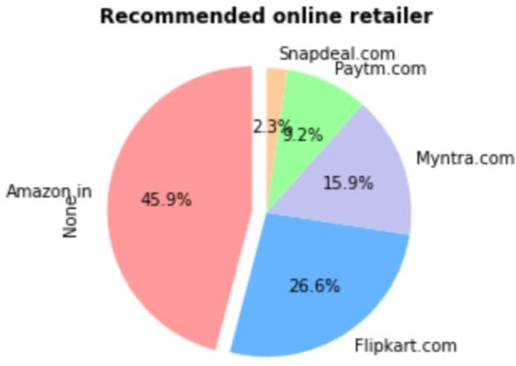

* + - * **Conclusion**
* This project provides various insights on how one can study the customer behaviour and uses it to build and grow e-retail business. For online retailers, marketers and retail website developers, the outcome of the study is of extreme importance to target a specific shopping segment(s).
* Various shopping values and web features influence the different groups of online shoppers.
* To run a successful online retail sore, emphasis must be given to the factors necessary for user satisfaction. However, these factors may differ among the customers as per their preferences.
* Some of the shoppers do e-shopping because of their convenience and usefulness, while many others rely on e-commerce to search products and offer information.
* Likewise, some segments are not interested to do online shopping to derive pleasure and fun. For example, information seekers are drawn to the web portals offering accurate product and service information and they may not be so interested in the entertainment value of online shopping. E-retailers targeting this community should concentrate their web elements on the theme ‘Reliability and Ease of Searching Products.’ Ensuring correct photos, product descriptions and ease of search for contextual cues can allow portals to attract this segment and gain loyalty.
* Students are a big part of the utility-seekers, as they actively concentrate on obtaining profit from online shopping. Portals targeting this category will concentrate on providing practical value to these shoppers either by increasing the use of portals or by reducing prices by providing promotional discounts. E-retail portals with a wide range of products to choose from would attract these shoppers and allow them to close their shopping trip in one case.
* Quality seekers are delighted by the monetary and practical advantages of online shopping as well as the fun they experience when browsing online portals. You can use portals that are fun to navigate and browse, and store the latest gadgets and trendiest items for heavy discounts.
* Increasing user experience and features such as built-in videos, the 3D view of items, chat mechanisms and customerto - customer interactivity can help attract more users and increase segment patronisation.
* Information, system and service qualities prove to be the well-established factors necessary for online business users’ satisfaction. Nevertheless, e-retailers are required to integrate other benefits as well to create value to the customer.
* The importance of the quality of system, information, accessibility, security, and ease of use are needed to appeal to the consumer’s utilitarian values.
* On the other hand, to appeal to the hedonistic values of the consumer, the e-store should incorporate elements that would offer value to the pleasure seeking behaviour of customers; for example: adventure, gratification, role shopping etc.
* A combined approach designed to increase customer satisfaction, trust, and the overall net benefits of shopping on their e-store must be adopted to achieve goals
* Online retailers must focus on the information quality and system quality of the online retail websites to enhance customer satisfaction, which in turn will lead to repurchase decision.
* Both the utilitarian and hedonistic values led to customer satisfaction and considerably stimulate their repurchase intention, leading to loyalty.
* The result further suggests that customers’ perception of utilitarian and hedonic values will inform their preference for a particular online store. Hence, attention to the customer specific content is very much vital.
* From the above study it is quite clear that “Amazon.in” and “flipkart.com” were pretty good in terms of providing satisfaction to the customers by fulfilling their hedonic and utilitarian needs.
* “Paytm” and “Snapdeal” lack customer retention strategies and should work upon the same. It is seen that paytm and snapdeal had attractive offers during the promotion and sales period but it is suggested they work more on the overall improvement of their applications/websites in order to attract more customers and retain the existing one.
* It is observed that content marketing could improve customer acquisition.
* It is hoped that the e-commerce platform and retailers will work together to pay attention to consumers’ preferences and perceived value, continuously improve management and service quality, and continuously improve consumer well-being and achieve a win-win situation for corporate profitability and consumer satisfaction.

**Github link for jupyter notebook: https://github.com/ankitamhetre/blog- article/blob/main/customer%20retention%20data%20analysis.ipynb**

**Thank-you**